EACS Dataset: A Real-World Academic Admit Card Dataset from Bangladeshi Educational Institutions for OCR and Document Verification Research

Baizid MD Ashadzzaman¹*,

¹Department of Computer Science and Engineering
International Islamic University Chittagong
Chattogram, Bangladesh

*Corresponding author : baizid.md.ashadzzaman@gmail.com

Abstract
The EACS Dataset (Exam Admit Card Dataset) is a specialized image-based dataset developed to address challenges in document verification and automated data entry within educational administrative systems. The dataset was collected over a four-year period (2022–2025) from the operational ERP platform (NationalSchoolIntra) of a Bangladeshi educational institution located in Chittagong. It comprises 4,407 unique admit card images, each standardized to a resolution of 800 × 460 pixels and stored in JPG format to ensure a balance between visual clarity and computational efficiency for machine learning applications.
A key characteristic of the dataset is its structural complexity. Each admit card contains nine distinct textual fields, including Student Name, Father’s Name, Mother’s Name, Roll Number, Student ID, Class, Session, Group, and Semester. The dataset captures real-world variability in font styles (predominantly serif fonts such as Times New Roman), alignment inconsistencies, and layout variations, making it particularly suitable for evaluating the robustness of Optical Character Recognition (OCR) systems and Document AI models.
To facilitate supervised learning and benchmarking, a corresponding CSV metadata file is provided, containing manually verified ground-truth annotations for each field. This enables precise evaluation at both character-level and word-level accuracy.
To ensure privacy protection and ethical compliance, all sensitive personal identifiers (such as phone numbers, email addresses, photographs, and other confidential attributes) have been removed or anonymized. Additionally, personal names (e.g., student, father, mother names , student id , student roll number) have been systematically randomized while preserving their structural and linguistic characteristics, ensuring that no real individual can be identified while maintaining the dataset’s utility for OCR research.
The dataset is intended for academic and non-commercial research, particularly in the areas of document analysis, OCR benchmarking, and automated verification systems. By making this dataset publicly available, we aim to support the development of secure, AI-driven solutions for educational document processing and fraud detection.
Keyword

EACS Dataset;Optical Character Recognition (OCR);Document Verification;Academic Fraud Detection;Educational Data Mining;Admit Card Dataset

Specifications Table

Specification | Details
Subject | Computer Science (Artificial Intelligence and Computer Vision)
Specific subject area | Document Image Analysis, Optical Character Recognition (OCR), and Educational Document Verification
Type of data | Images (JPG format) and Tabular Data (CSV format)
How the data was acquired | Data was digitally extracted from the NationalSchoolIntra ERP system and through manual scanning of physical examination records
Data format | Raw images and processed ground-truth metadata (CSV)
Description of data collection | The dataset consists of 4,407 unique academic admit cards collected between 2022 and 2025. Each image has been standardized to a resolution of 800 × 460 pixels
Data source location | Institution: Al Quran Academy Chittagong City/Town: Boalkhali, Chittagong Country: Bangladesh
Data accessibility | Repository name: KaggleDirect URL: https://www.kaggle.com/datasets/baizidmdashadzzaman/exam-admit-card-dataset

Value of the Data

- Benchmarking OCR and Vision Models: This dataset provides a specialized benchmark for evaluating the accuracy of various Optical Character Recognition (OCR) engines, such as Tesseract, EasyOCR, and Llama Vision, specifically on structured academic documents with serif fonts.
- Advancing Document Forgery Research: The EACS dataset serves as a critical resource for researchers developing AI-powered systems to detect tampered or fraudulent academic credentials, which is a major concern for educational integrity.
- Real-World Complexity: Unlike synthetic datasets, these images are sourced from a live ERP system (NationalSchoolIntra), capturing real-world variations in document layout, alignment, and printing quality spanning four years (2022–2025).
- Automation in Educational Administration: The data is highly valuable for developers building automated verification pipelines for school management systems, reducing the need for manual, error-prone human inspections during examinations.a
- Resource for Low-Resource Languages/Regions: While the text is in English, the document structure is representative of South Asian academic formats, providing a unique dataset for regional document analysis research.

1.Data Description

The Exam Admit Card Dataset (EACS) is designed to support research in document intelligence, Optical Character Recognition (OCR), and educational document verification systems. The dataset consists of high-resolution images of academic admit cards along with corresponding structured ground-truth metadata.

1.1. Image Data (JPG Files)
- Number of images: 4,407 JPG files
- Resolution: 800 × 460 pixels
- Content: Digital representations of examination admit cards issued by Al Quran Academy, Chittagong
- Visual Features: Structured layout including institutional logo, student photograph area, and textual fields printed primarily in Times New Roman font
- Diversity: Covers five academic sessions (2022–2025), capturing variations in text alignment and printing quality
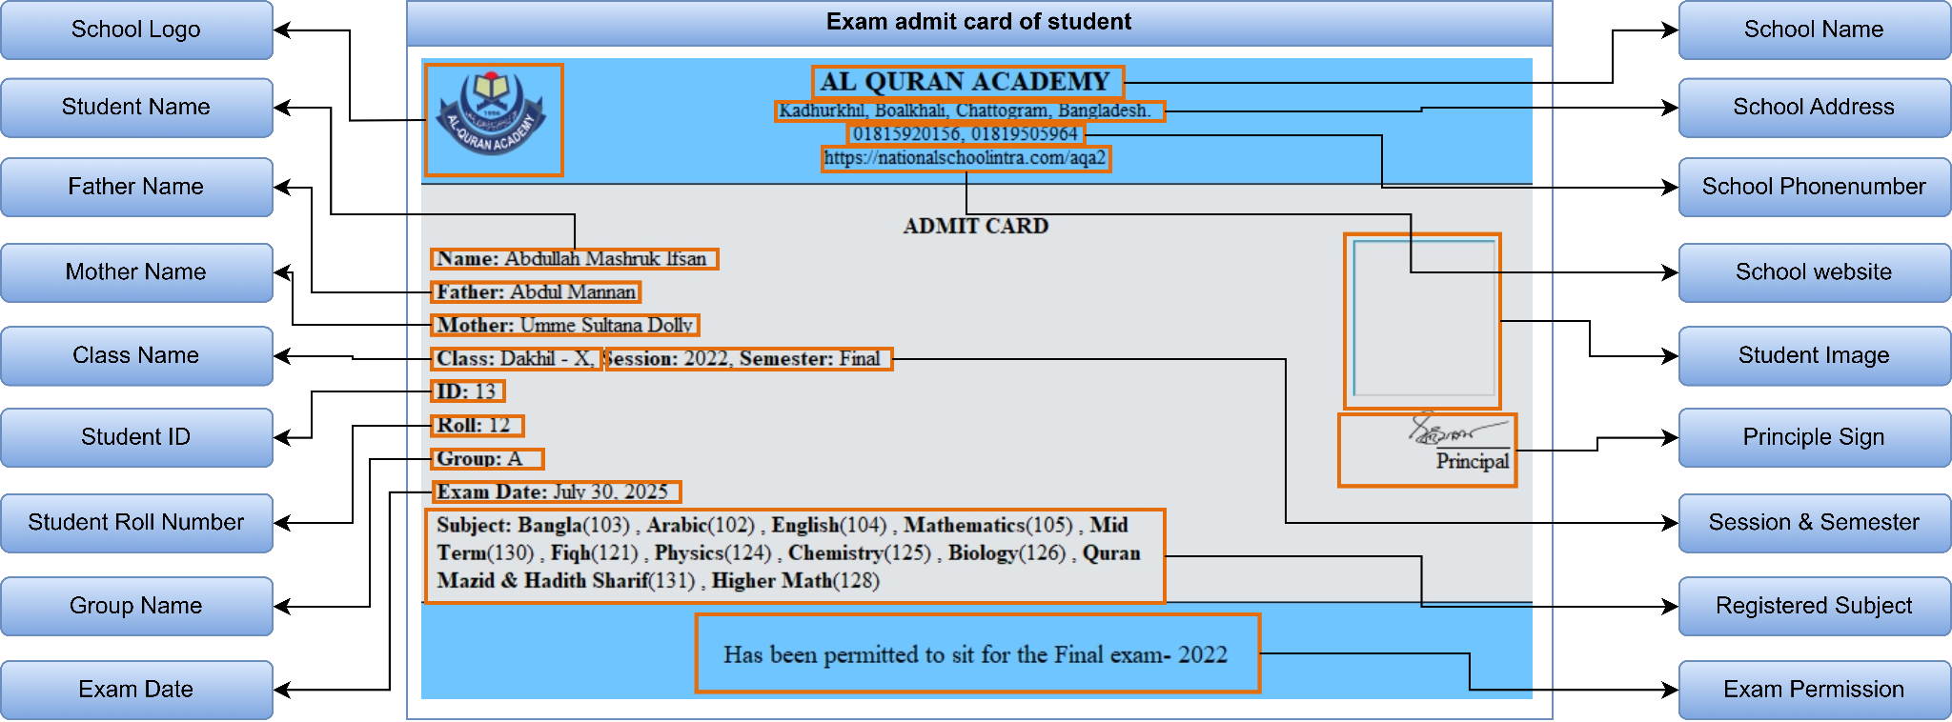
Figure 1: Visual representation of document layout and bounding boxes for metadata extraction. The diagram illustrates how institutional information (e.g., School Name, Logo) and student-specific fields (e.g., Name, Roll, Registered Subjects) are mapped within the EACS dataset.

1.2. Dataset Distribution and Diversity

The dataset covers academic sessions from 2012 to 2025. To ensure robustness for AI training, the data includes a wide variety of academic classes and groups.

Class-wise Distribution: Figure 2 shows the distribution of student records across different grade levels and sessions, highlighting the significant volume of data available for more recent years.
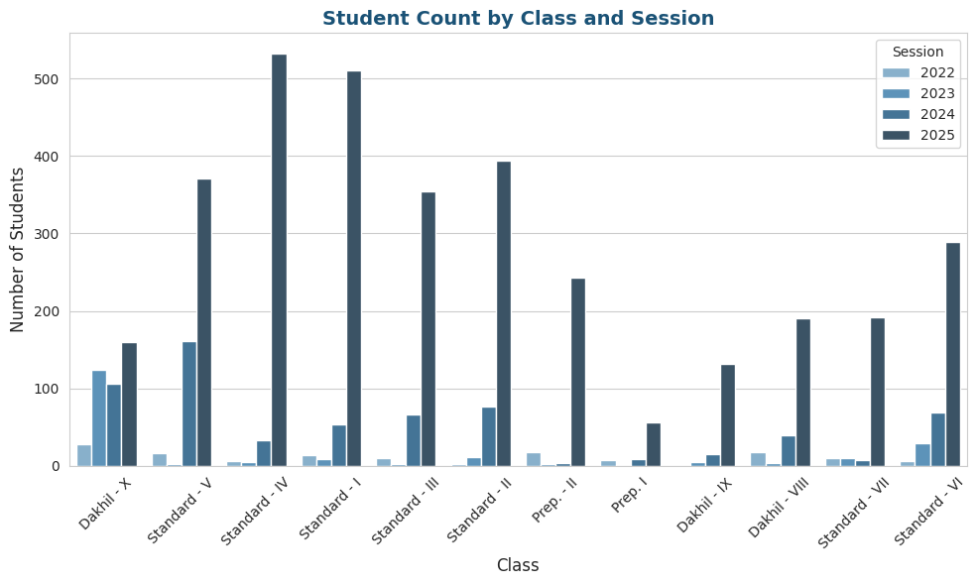

Figure 2: Bar chart showing student counts by academic class and session.

Group-wise Distribution: Figure 3 illustrates the demographic and academic stream diversity within the dataset, including categories such as Boys, Girls, Science, and General groups.

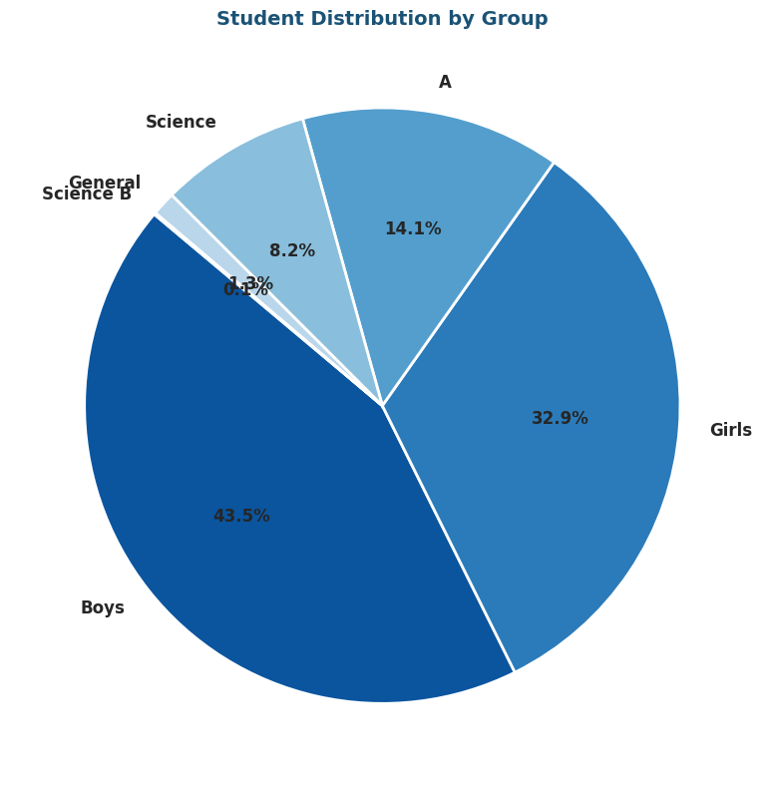

Figure 3: Pie chart representing the percentage distribution of students across different academic groups and genders

Subject Frequency: The textual variety within the dataset is demonstrated in Figure 4, which shows the most common subjects and their occurrence frequency. This variety is crucial for training OCR models to recognize diverse academic terminology and codes.
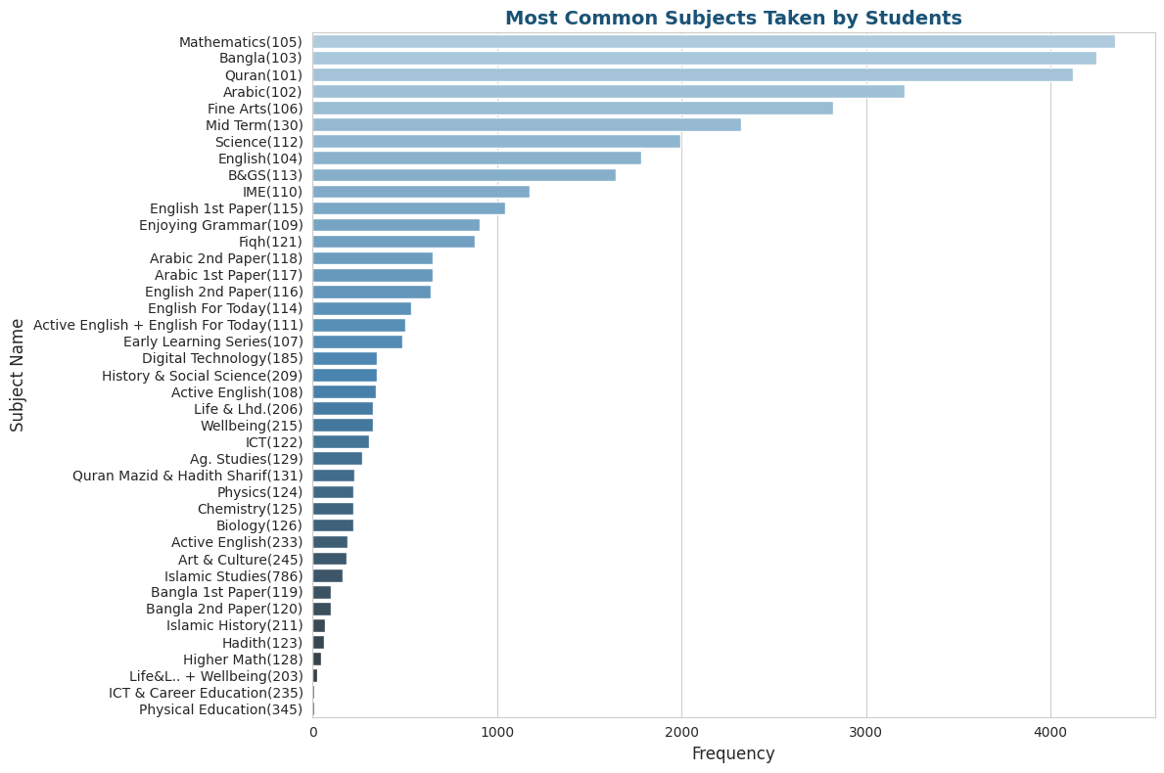

Figure 4: Horizontal bar chart showing the frequency of different subjects within the dataset, highlighting the textual diversity for OCR benchmarking.

- Name Length Complexity: To assist in UI/Design benchmarking and character-level recognition, Figure 5 illustrates the distribution of name lengths (characters) for students and their parents. This variability is essential for testing the adaptability of OCR systems to different string lengths.

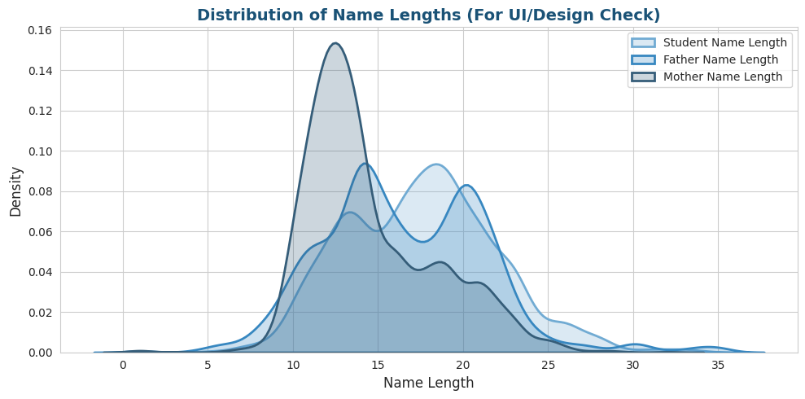
Figure 5: Kernel Density Estimation (KDE) plot showing the distribution of name lengths for students, fathers, and mothers, indicating the lexical diversity of the dataset.

1.3. Ground-Truth Data (CSV File)
- File name: admit_card_metadata.csv
- Description: Annotated text for each admit card image to facilitate character-level and word-level accuracy evaluation
- Column Descriptions:
Column Name | Description | Data
admit_card_image | Unique filename of the admit card image. | 14-699-1-1-1-1.jpg
student_id | Institutional unique identification number. | 14
student_name | Full name of the student as printed on the card. | Abid Anwar
father_name | Full name of the student's father. | Mohammed Nurul Anwar
mother_name | Full name of the student's mother. | Mosammat Sabekun Nahar Shafu
class | The academic grade level of the student. | Dakhil - X
session | The academic year/session of the examination. | 2022
semester | The specific exam term or period. | Final
group | Academic stream or group (e.g., Science/Arts). | A
roll | The unique examination roll number. | 13
exam_date | The scheduled date of the examination. | 30-Jul-25
subjects | List of registered subjects with their codes. | Bangla (103), Arabic (102), English (104), Mathematics (105), Mid Term (130), Fiqh (121), Physics (124), Chemistry (125), Biology (126), Quran Mazid & Hadith Sharif (131), Higher Math (128)

1.3. Data Quality and Preprocessing
The images are pre-aligned to ensure that textual fields are located in predictable regions. The ground-truth CSV was cross-checked against the NationalSchoolIntra ERP database, ensuring 100% annotation accuracy.

2. Experimental Design, Materials and Methods

2.1. Data Sourcing and Collection
The primary source of the dataset is the NationalSchoolIntra ERP (Enterprise Resource Planning) platform, which manages student records for Al Quran Academy, Chittagong. Digital examination records from the 2018–2023 academic sessions were exported and compiled to create a statistically significant dataset suitable for training and evaluating OCR-based systems. A total of 4,407 admit cards were collected, representing a diverse range of print layouts and text styles over five academic sessions.

2.2. Image Preprocessing and Standardization
To ensure uniformity and usability for machine learning and computer vision applications, the following preprocessing steps were applied:
- Uniform Resizing: All images were standardized to a resolution of 800 × 460 pixels, maintaining text legibility while optimizing file size for computational processing.
- Format Conversion: Images were saved in JPG format for broad compatibility with vision-based frameworks.
- Privacy Masking: Sensitive information was handled according to institutional privacy guidelines while preserving the structural integrity of the admit cards.

2.3. Ground-Truth Annotation Process
The ground-truth metadata was generated using a two-step annotation process to ensure 100% accuracy:
- ERP Metadata Sync: Textual data including student name, roll number, ID, and other details were mapped directly from the institutional SQL database to ensure consistency with official records.
- Manual Verification: Each CSV entry was cross-checked against its corresponding image by human annotators to verify the fidelity of printed text relative to digital labels.

2.4. Dataset Accessibility and Structure
The finalized dataset is publicly available on Kaggle . Images and metadata are organized to facilitate ease of use: researchers can link image files with CSV annotations using the Image_ID field as the primary key. This structure enables straightforward integration into machine learning pipelines for OCR, document layout analysis, and automated verification systems.

3. Ethics Statement

The ethical considerations and data privacy protocols for the EACS Dataset were strictly managed as follows:
- Institutional Approval and Consent: The dataset was compiled and published with formal authorization from the administration of Al Quran Academy, Chittagong. Since the data was originally generated and stored within the NationalSchoolIntra ERP system for official academic purposes, the institution provided explicit permission to use these records for research, benchmarking, and the development of document verification technologies.
- Anonymization and Data Privacy: To protect the identity and privacy of the students, the following measures were implemented before public release:
  - Selective Data Inclusion: Only fields necessary for OCR training and document layout analysis (e.g., Name, Roll, Session) were included.
  - Visual Redaction: Sensitive personal identifiers such as signatures, residential addresses, or specific contact numbers (if any were present in the original records) were manually reviewed and redacted/masked to ensure compliance with privacy standards.
  - Institutional Identity: The institutional branding (logos and headers) remains intact to maintain the dataset's structural authenticity for document AI research, as authorized by the school.
- Data Usage Compliance: The collection and dissemination of this data comply with the ethical guidelines for the secondary use of administrative data in educational research. The dataset is intended solely for academic and non-commercial purposes, specifically to improve automated verification systems and prevent academic fraud.
- No Risk to Participants: As the dataset consists of historical records (2018–2023) used for the sole purpose of validating digital verification systems, there is no physical, psychological, or legal risk to the students whose records are represented in the dataset.

Credit Author Statement

Baizid MD Ashadzzaman: Conceptualization, Data curation, Methodology, Software, Validation, Investigation, Visualization, Writing original draft, Writing review & editing.

Acknowledgment

The authors would like to express their sincere gratitude to the administration and management of Al Quran Academy, Chittagong, for granting permission to access and utilize their institutional records for this research. Their support in providing digital examination archives was fundamental to the creation of the EACS Dataset.
Special thanks are extended to the technical support team of the NationalSchoolIntra ERP platform. Their assistance in navigating the database and ensuring a seamless extraction of the digital admit card records from the 2018–2023 academic sessions was invaluable.
Furthermore, we acknowledge the contributions of the research assistants and student volunteers who assisted in the manual verification of the ground-truth metadata, ensuring the high quality and reliability of the dataset. Finally, the authors are grateful to the open-source community for providing the computational tools and platforms (Kaggle) that facilitate global data sharing and collaborative research.
.
Declaration of Competing Interest

The authors declare that they have no known competing financial interests or personal relationships that could have appeared to influence the work reported in this paper.
References

- [Apnar Main Paper-er Reference]: [Apnar Naam], et al., "Automated Academic Document Verification Using Deep Learning and OCR," Journal Name (Submitted), 2026. (Jodi main paper ekhon-o publish na hoye thake, tobe 'Submitted' ba 'In Press' likhte paren).
- [Dataset Source Reference]: NationalSchoolIntra, "Enterprise Resource Planning (ERP) for Educational Institutions," Al Quran Academy, Chittagong, Bangladesh, 2023. [Online]. Available: https://nationalschoolintra.com/
- [Dataset Repository Reference]: [Apnar Naam], "EACS: Exam Admit Card Dataset for Document AI," Kaggle Datasets, 2024. [Online]. Available: https://www.kaggle.com/datasets/baizidmdashadzzaman/exam-admit-card-dataset
- [Relevant Technology Reference]: Smith, R., "An Overview of the Tesseract OCR Engine," Proceedings of the Ninth International Conference on Document Analysis and Recognition (ICDAR), Vol. 2, pp. 629–633, 2007.
- [Data in Brief Methodology Reference]: Elsevier, "Data in Brief: Guide for Authors," 2024. [Online]. Available: https://www.elsevier.com/journals/data-in-brief/2352-3409/guide-for-authors

